Lab - Create User Accounts

Introduction
In this lab, you will create and modify user accounts in Windows.
Part 1: Creating a New Local User Account
Part 2: Reviewing User Account Properties
Part 3: Modifying Local User Accounts

Required Resources
- A Windows PC

Instructions

Creating a New Local User Account

Open the User Account Tool.
      - Log on to the Windows PC with an Administrator account. The account CyberOpsUser is used in this example.
      - Click Start > search Control Panel. Select User Accounts in the Small icons view. To change the view, select Small icons in the View by drop down list.

Create a user account.
      - In the User Accounts window, click Manage another account.
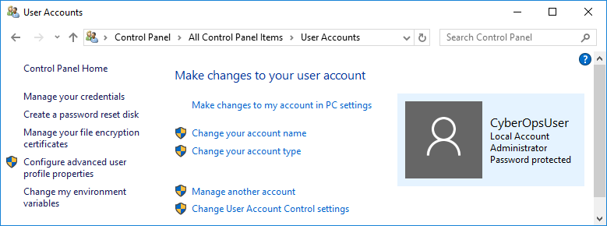
      - In the Manage Accounts window, click Add a new user in PC settings.
      - In the Settings window, click Add someone else to this PC.
      - In the How will this person sign in? window, click I don't have this person's sign-in information.
      - In the Let's create your account window opens, click Add a user without a Microsoft account.
      - In the Create an account for this PC window, provide the necessary information to create the new user account named User1. Click Next to create the new user account.

Question:
What type of user account did you just create?
Type your answers here.
      - Attempt to log into the newly created user account. It should be successful.
      - Navigate to C:\Users folder. Right-click the User1 folder and select Properties, and then the Security tab.

Question:
Which groups or users have full control of this folder?
Type your answers here.
      - Open the folder that belongs to CyberOpsUser. Right-click the folder and click the Properties tab.

Question:
Were you able to access the folder? Explain.
Type your answers here.
      - Log out of User1 account. Log back in as CyberOpsUser.
      - Navigate to C:\Users folder. Right-click the folder and select Properties. Click the Security tab.

Question:
Which groups or users have full control of this folder?
Type your answers here.

Reviewing User Account Properties
      - Click Start > Search for Control Panel > Select Administrative Tools > Select Computer Management.
      - Select Local Users and Groups. Click the Users folder.
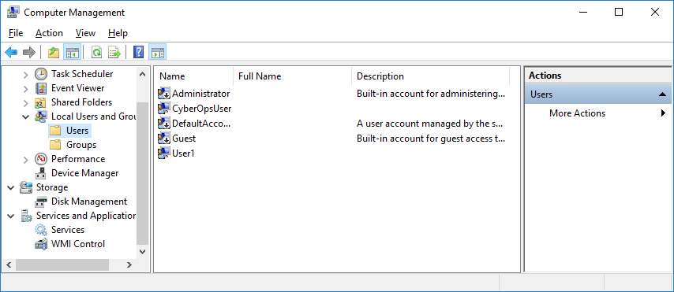
      - Right-click User1 and select Properties.
      - Click the Member Of tab.

Question:
Which group is User1 is a member of?
Type your answers here.
      - Right-click the account CyberOpsUser and select Properties.

Question:
Which group is this user a member of?
Type your answers here.

Modifying Local User Accounts

Change the account type.
      - Navigate to the Control Panel and select User Accounts. Click Manage another account. Select User1.
      - In the Change an Account window, click the User1 account. Click Change the account type.
      - Select the Administrator radio button. Click Change Account Type.
      - Now the account User1 has administrative rights.
      - Navigate to Control Panel > Administrative Tools > Computer Management. Click Local Users and Groups> Users.
      - Right-click User1 and select Properties. Click Member Of tab.

Question:
Which groups does User1 belong to?
Type your answers here.
      - Select Administrators and click Remove to remove User1 from the Administrative group. Click OK to continue.

Delete the account.
      - To delete the account, right-click User1and select Delete.
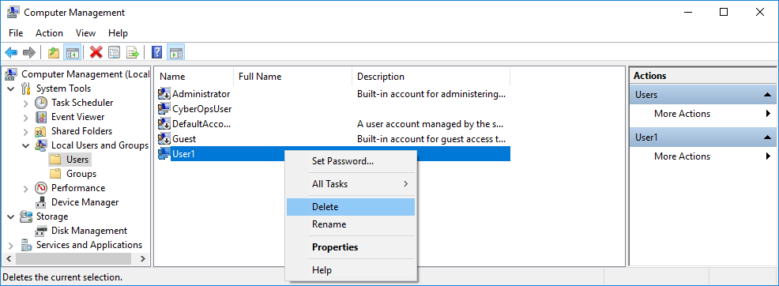
      - Click OK to confirm the deletion.

Question:
What is another way to delete a user account?
Type your answers here.

Reflection Questions
  - Why is it important to protect all accounts with strong passwords?
Type your answers here.
  - Why would you create a user with Standard privileges?
Type your answers here.
End of document

